Practical activity: Observing the migration of ions
Demonstration Guide – Migration of Ions

Aim: To investigate the migration of ions during electrolysis as evidence for the ionic model
Notes and guidance
This practical involves the use of a 40 V power supply. This is a potentially dangerous piece of equipment, so this experiment should be carried out as a demonstration. If available, a visualiser or digital camera should be utilised so students get a clear view.

This practical may work on lower voltages, but anything below 20 V will see much slower and less obvious results.

Potassium permanganate crystals can create a lot of mess. Ensure paper towels and a good supply of running water are at hand in case of any accidents. Consult CLEAPSS Hazcards for most recent safety and disposal advice.

Speak with your technician colleague in advance of this practical as they may need time to prepare resources.

Risk Assessment Notes
A risk assessment must be completed for this practical. The risk assessment should be specific to the class involved and written only by the teaching member of staff. For more guidance refer to CLEAPSS. It is good practice for students to wear safety spectacles during all class practicals and demos.

Potassium permanganate crystals can create a lot of mess. Ensure paper towels and a good supply of running water are at hand in case of any accidents. Consult CLEAPSS Hazcards for most recent safety and disposal advice.

Ensure that power supplies are locked so they cannot exceed 40 V. Liquids should be kept a safe distance from power supplies and any spills should be cleaned up immediately.

Equipment | Migration of Ions Slide Setup  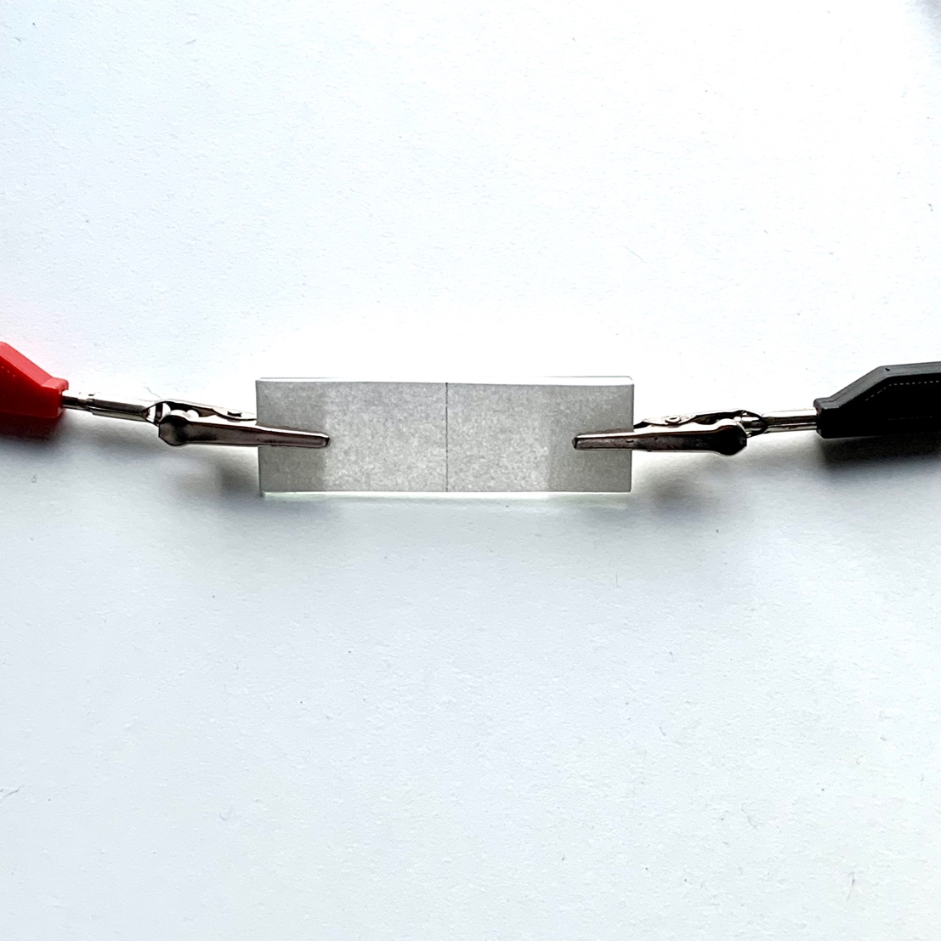
Apparatus:
- Microscope slide
- Filter or chromatography paper
- Scissors
- Tweezers
- D.C. power supply (40 V)
- Wires and crocodile clips

Chemicals:
- Potassium manganate(VII) (permanganate) – crystal form

Method |  | Questions To Ask Students During The Demonstration
- Using the scissors, reshape the filter paper to be slightly longer than the glass microscope slide, but the same width.  - Use a pencil to draw a central dividing line across the width of the paper.  - Moisten the filter paper with tap water then shake off any excess.  - Place the moistened paper on the glass slide and fold over the longer sides.  - Use crocodile clips to attach leads from the power supply to each side of the slide. Do not switch the power supply on yet. Make a note of which end is positive and which is negative.  - Carefully place one small crystal of potassium manganate(VII) onto the filter paper in the centre of the pencil line.  - Ensure the power supply is set to 20 V D.C. and switch it on.  - Leave the apparatus to run for 20-30 minutes. Note any observations. |  | - Why do we cut the filter paper slightly longer than the glass slide? (So we can fold the paper over and give the crocodile clip a good surface to attach to on both sides. The moistened paper conducts electricity and provides more friction than the glass.)  - Why do we use tweezers to position the crystal of potassium manganate(VII)? (If we use our fingers, its interaction with the moisture on our skin will create a potentially harmful mess.)  - Why is it important to ensure the two crocodile clips do not touch one another? (This would create a short circuit and no electricity would pass through the moistened filter paper.)  - What do we observe after the power supply is switched on? (Soon after being placed on the paper, the crystal’s purple colour begins to diffuse. Once the power is switched on, the purple area slowly begins to grow in the direction of the positive electrode. After twenty minutes, a flare in the direction of the positive electrode is clearly visible.)  - How can we explain this? (In solution, potassium manganate(VII) releases mobile, negatively charged manganate(VII) ions. These are attracted towards the oppositely charged positive terminal.)
Alternative Methods/Computer Simulations
If you would like to demonstrate the migration of ions towards the negative terminal, another coloured salt such as iron(III) chloride would be appropriate. However, the effect will not be as clear as with the bold purple colour of potassium manganate(VII).

There are many videos of this experiment being conducted online. Many of these feature a timelapse sequence where the migration of ions can be seen clearly. It is worth finding one of these just in case the experiment fails.

Clearing up
It is important that equipment is returned to the prep room in good order. If safe to do so, rinse used equipment and put it in the used equipment tray. If the trays arrived on a trolley, students must return all trays and equipment to that trolley. Anything dirty needs to be placed into a separate container for washing up. Never put dirty equipment back into a tray with clean equipment.

Technician Notes
Ensure the solutions you provide are free from contamination and the equipment is as clean as possible.

Discuss this practical with the class teacher ahead of time. Ensure they have considered the risks of this practical and are confident with the techniques used. If necessary, provide them with the appropriate CLEAPSS so they are comfortable with the chemicals to be used and how to use and dispose of them safely.

